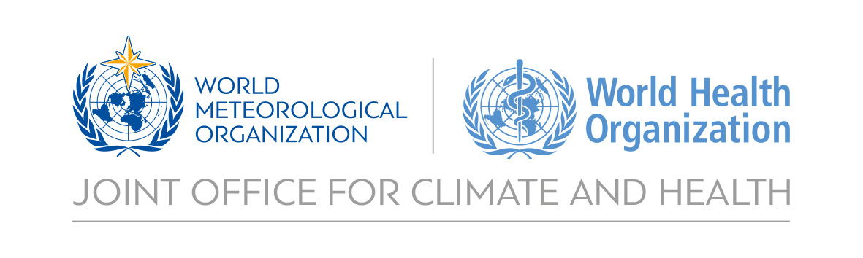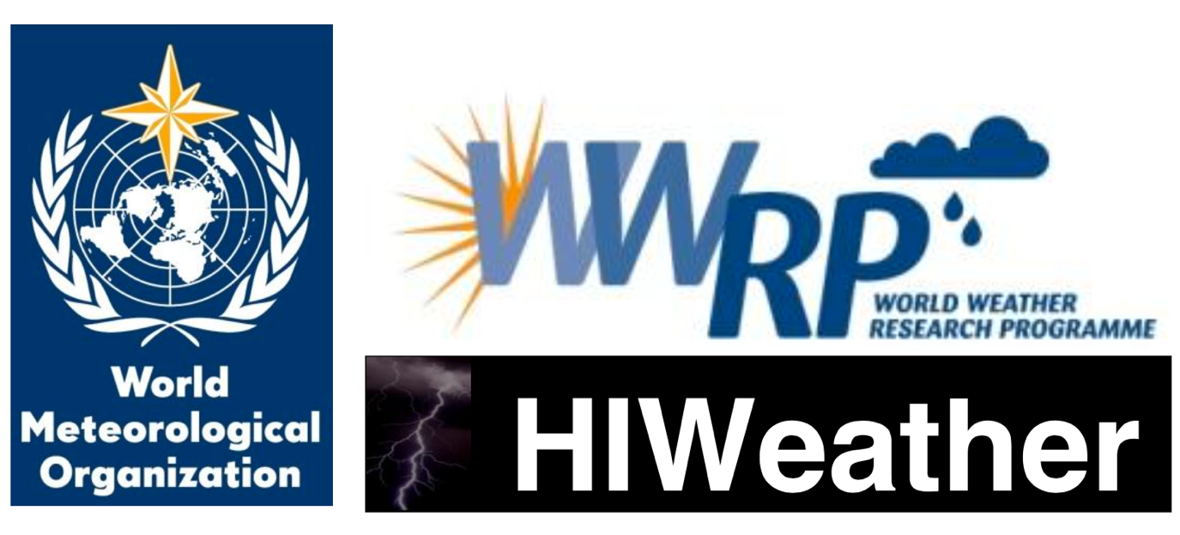

**White Paper on Health Linkages to HIWeather**

**Draft outline**

**Version: 22nd August 2017**

Table of contents

Figures and tables 2

1. Introduction 3

2. Structure of white paper 3

3. Decision-making processes in disaster action plans 4

1. Decision-making structure 4

2. Iterative management of decision-making structure 4

3. Identity of decision makers 5

4. Timeline of key decisions and processes 5

4. Key metrics to track health impacts of and vulnerability to disasters 7

Outlines of HIWeather focus areas 8

1. Urban Flood 8

Overview 8

Health impacts 8

Key processes made in preparedness and action plans 9

Key gaps in real-time monitoring, forecasting and alert capabilities 10

Key opportunities to develop or improve health relevant deliverables 10

Potential projects with improved forecasting 11

References 12

# Figures and tables

Figure 1. Potential flow of information between a lead body and other actors involved in heat action plans. 4

Figure 2. Communications plan for Ahmedabad Heat Action Plan 5

Figure 3. Schematic representation of time frames set out by WHO for implementing the core elements of a heat action plan.3 6

Table 1. Key focal areas of HIWeather and the outline in this report for each. 3

Table 2. Indicators from monitoring processes relevant to disasters. 7

# Introduction

Disaster globally since 1990 have caused the deaths of over 1.6 million people.1 High Impact Weather (HIWeather), a research activity within the World Weather Research Programme (WWRP), aims to improve extreme weather event forecasting, both in spatial resolution and predictive lead time. A significant beneficiary of HIWeather products could be decision makers in disaster early warning systems and emergency health care provision, who would be able to use improved forecasting techniques to better prepare for approaching extreme weather.

However, a significant knowledge gap exists in the HIWeather operation plan in terms of **where**, **when**, and **how** significant health care decisions are made. Further, missing is a detailed awareness of how much lead time is needed for health care decisions. If a significant goal of HIWeather is to improve health outcomes by successful utilisation of its products, the direction of improved HIWeather products must be steered by the awareness and knowledge of the nature of disaster-related health care decisions by the end user in the ‘last-mile’.

This white paper aims to give an exposition on the process by which health care decision makers build a timeline of required action. The report will be structured around each of the 5 areas of focus of HIWeather. **The logic of this approach is to begin with the desired health outcome improvements, and work systematically through the processes to identify where HIWeather products could be applied or tailored to assist the health sector.**

In this way, the selection and development of HIWeather products will be able to use health impacts at the heart its direction.

# Structure of white paper

The report begins with an overview of **key decision-making processes and timelines**, as well as **key metrics as trackers for disaster-related health outcomes**. It then outlines a series of health aspects relevant to each of the 5 HIWeather Focus areas (Table 1):

Table 1. Key focal areas of HIWeather and the outline in white paper for each area.

|  |  |
| --- | --- |
| HIWeather Focus Areas | Areas of Health Linkages to be outlined for each Focus Area |
| 1. urban flood 2. wildfire 3. localised extreme wind 4. disruptive winter weather 5. urban heat waves and air pollution | * **Health impacts.** Identify key health impacts related to each focus weather hazard area. * **Timeline of key decisions and processes.** Create timeline of decisions which need to be made by key decision makers. * **Key gaps in capabilities.** Identify key gaps in capabilities of forecasting (both in time and space) which can be improved upon to help decision makers make decisions.   **Key deliverables.** To improve capabilities of decision-makers to avert disaster-related deaths.  **Potential projects with improved forecasting.** Potential projects serving as focused health outcome-based research for HIWeather. |

# Decision-making processes in disaster action plans

## Decision-making structure

When disasters are forecast, it is important that a consolidated well-functioning decision-making process is in place to enable a smooth roll-out of emergency measures. At key points in the disaster-forecasting timeline, there are essential communication pathways between decision makers and practitioners. The Sendai Framework for Disaster Risk Reduction 2015-2030 makes strengthening disaster risk governance to manage disaster risk one of its four priorities for action.2

Figure 1 demonstrates the potential flow of information between decision-makers during consideration of activating a Heat Health Action Plan (HHAP)3. Figure 2 showcases an example, from the Ahmedabad Heat Action Plan, with more detail on the methods of communication between decision makers and practitioners.

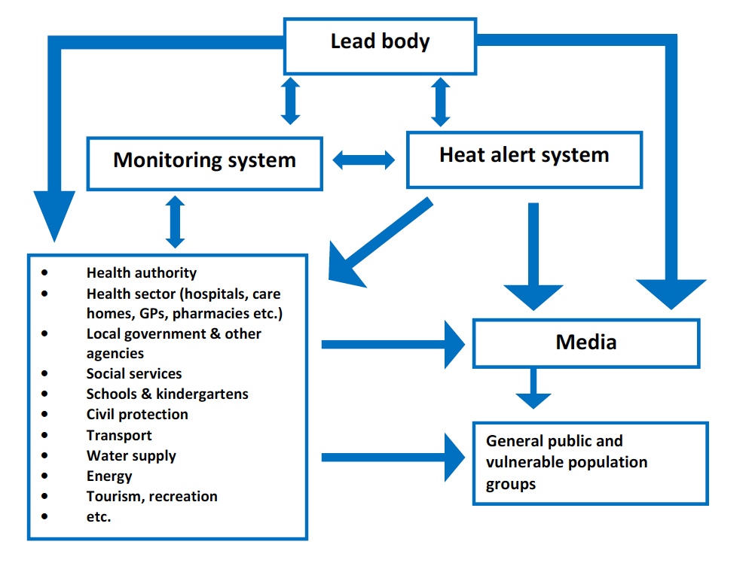

Figure 1. Potential flow of information between a lead body and other actors involved in heat action plans.

## Iterative management of decision-making structure

While it is important to set up a clear disaster management decision-making structure, it is crucial that these systems of management are reassessed iteratively over time, especially for when the structure is in place with a calendar year, if, for example with a heat wave action plan, the occurrence and management of disaster is only required at certain times of the year.4

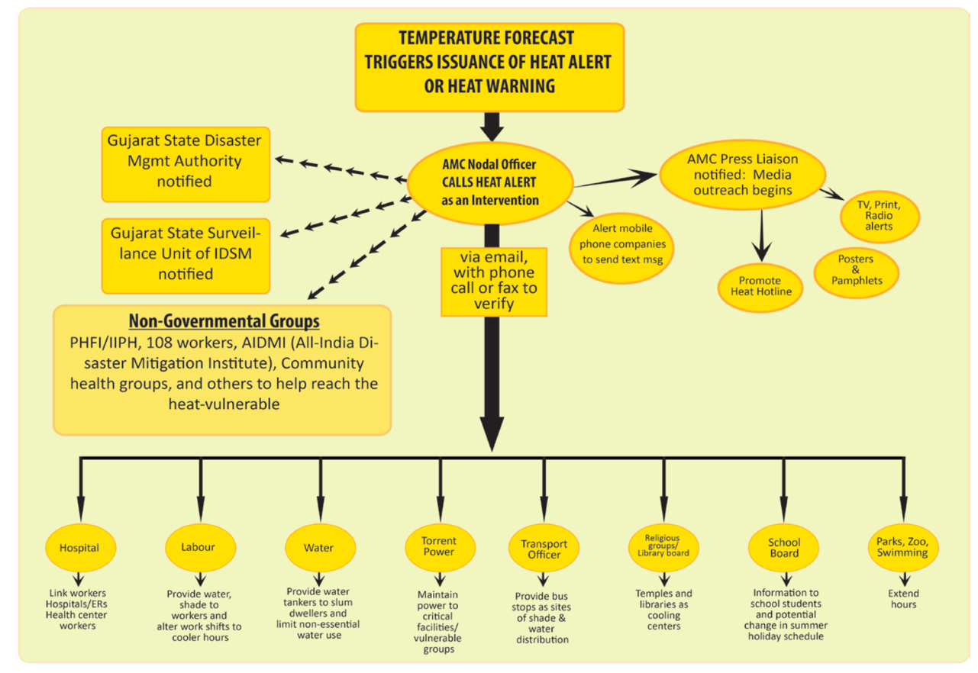

Figure 2. Communications plan for Ahmedabad Heat Action Plan

## Identity of decision makers

A decision maker will need key pieces of information in a timely manner to be able to make the correct calls for disaster planning. This includes, but is not exclusive to:

* National and local government
* Employers and private sector
* Social and advocacy groups
* Community groups
* Health practitioners

## Timeline of key decisions and processes

WHO recommends an approach with five time frames, which cover long-term preparation as well as responses after the disaster5 :

* Longer-term development and planning
* Timely preparations before summer (pre-summer)
* Prevention during the summer
* Specific responses to periods of heat/heat waves
* Monitoring and evaluation

These timelines are depicted in Figure 3, addressing heat wave preparation:

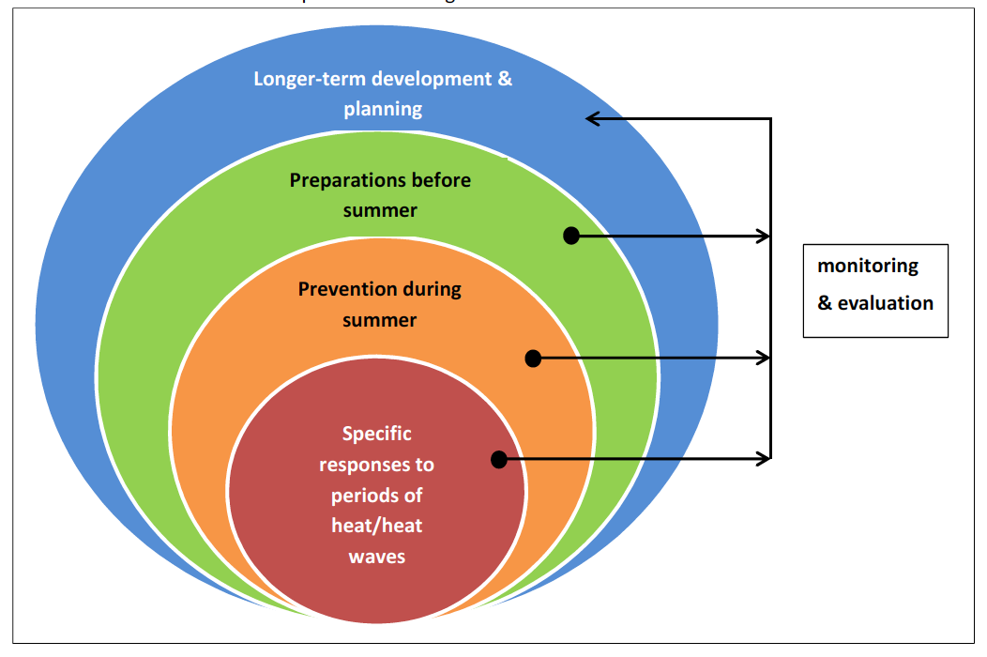

Figure 3. Schematic representation of time frames set out by WHO for implementing the core elements of a heat action plan.3

# Key metrics to track health impacts of and vulnerability to disasters

Disaster-related metrics provide a key quantification of the effect of disasters on mortality. Several monitoring processes include relevant indicators (Table 2):2,6,7

Table 2. Indicators from monitoring processes relevant to disasters.

|  |  |  |
| --- | --- | --- |
| **Monitoring process** | **Disaster(s) relevant** | **Indicator** |
| Lancet Countdown | 5 | 1.2 Health effects of heatwaves |
| 1,2,3,4,5 | Climate-resilient health infrastructure |
| Sendai Framework for Disaster Risk Reduction | 1,2,3,4,5 | A-1: Number of deaths and missing due to hazardous events per 100,000 |
| 1,2,3,4,5 | A-2 Number of deaths due to hazardous events |
| 1,2,3,4,5 | A-3 Number of missing due to hazard events |
| 1,2,3,4,5 | B-1 Number of affected people per 100,000 |
| 1,2,3,4,5 | B-2 Number of injured or ill people due to hazardous events |
| 1,2,3,4,5 | B-3 Number of people who left their places of residence due to hazardous events |
| 1,2,3,4,5 | B-3a Number of evacuated people due to hazardous events |
| 1,2,3,4,5 | B-3b Number of relocated people due to hazardous events |
| 1,2,3,4,5 | B-4 Number of people whose houses were damaged due to hazardous events |
| 1,2,3,4,5 | B-5 Number of people whose houses were destroyed due to hazardous events |
| 1,2,3,4,5 | B-6 Number of people who received food relief due to hazardous events. |
| Sustainable Development Goals | 1,2,3,4,5 | 1.5.1 Number of deaths, missing persons and persons affected by disaster per 100,000 people |
| WHO Climate and Health Country Profiles | 5 | Heat-related mortality |
| 1 | Exposure to flooding due to sea level rise |

# Outlines of HIWeather focus areas

## 1. Urban Flood

### Overview

Urban floods can arise from extreme thunderstorms (manifested as flash floods), or from river overflow. Both rapid rise and slow rise floods can have a significant impact on public health in an urban area.8 Between 1995 and 2015, 3,062 flood events were recorded9. Floods were responsible for the majority (56%) of natural disasters; affecting 2.3 billion people worldwide9. While the adverse health effects of flooding include direct impacts on human health, the pathways can be complicated and indirect.

### Health impacts

#### Immediate onset which can be informed by Public Weather Services

**Disruption to essential health care.** Treatment for serious illnesses, such as cancer, can be disrupted by flooding, due to transport infrastructure being knocked out for prolonged periods of time.10 Lack of availability of routine prescription medicines due to flooding may also impact health.11 Health care practitioners may also become overwhelmed by the increased demand for services.8

**Drowning or physical trauma.** Rapid rise floods can cause sudden changes to the environment, increasing the risk of drowning and injuries.12 Slow rise floods can also be deadly when there is a lack of preparedness.8 Injuries may include snake or other bites, and electrocution due to power lines.

**Facilitating Disease transmission.** Diseases can be spread from undisinfected groundwaters by the onset of flooding.13 Flooding of sanitation facilities, disruption to safe drinking water sources, poor hygiene, contact with contaminated surface waters, displacement and contact with other vectors such as rodents. Increased instances of cholera14, diarrheal diseases14, hepatitis A and E14, leptospirosis14, melioidosis15, respiratory infections16, and typhoid14 have been observed after floods in urban areas.

#### Impacts with longer-term onset related to flood events

**Malaria.** Epidemics in the wake of flooding in tropical regions can occur due to clogging of storm water drains, causing stagnant water to allow genesis of vectors of malaria.16,17

**Malnutrition.** Damage to infrastructure caused by flood, and disruption to food systems can cause appropriate food to be unavailable for prolonged periods, with children and the elderly particularly in developing countries vulnerable.18

**Psychological distress.** The mental health effects of a flood can last long after the flood itself, with reports of increased prevalence of psychological morbidity (including depression, anxiety, PTSD) in residents up to 1 year after floods, particularly if residents are displaced at short notice.19,20

### Key processes made in preparedness and action plans

#### Climate prediction (outside core interest of HIWeather but of interest to WCRP)

Long-term actions (years) i.e. long-term forecasts and projections:

**Adaptation of buildings and urban infrastructure in vulnerable flood plains.** A long-term preparedness action requires a detailed knowledge of potential flood plains and river overflows. Long-term adaptive action is important in both industrialised and developing nations to safeguard health of vulnerable communities.

**Flood barriers.** Building and planning using high-resolution modelling must be enacted long before a flood. Appropriate flood barriers require building to defend against a flood with a return period chosen after flood modelling.21

**Protection of drinking water sources.** Long-term decisions in urban areas include slow sand filters, which are also appropriate for large cities like London or Amsterdam, and routing permanent water supplies to avoid potential contamination.22 In developing countries, wells may still be the primary source of water, even in urban areas. Raising the head wall of a dug well, and providing a cover and outward-sloping concrete apron around it is one such way of providing additional security to the supply.22

#### Weather prediction (in core interest of HIWeather and WWRP)

Mid-term actions (months) i.e. S2S forecasting:

**Drilling staff and citizens for urban flood scenarios.** Finding and training reliable staff for a flood scenario requires significant resources. In addition, holding discussions with vulnerable communities about action plans for floods is important to maximise the effectiveness of contingencies.22

Short-term actions (weeks, days, hours, minutes) i.e. nowcasting, short-term forecasting:

**Evacuation of low lying communities and health facilities.** Up to 3 days may be required for an effective evacuation of a densely-populated urban area.

**Providing alternative water sources.** Vulnerable communities may be isolated for days. As such, they will need to ensure they have drinking supplies for this requisite time. 15 litres per person, per day is a recommended amount, while 7 litres per person is classed as a minimum.22 This can be alleviated by supplying mobile purification units connected to the nearest untreated source22

**Provision of emergency food supplies.** Three days-worth of food to build up [ref= https://www.ready.gov/floods]

**SOPs for emergency medical transport services during floods.**

**Emergency shelter preparation for displaced communities.** Communities displaced may have to reside in temporary shelters. Like food and medical supplies, this may require days of advance preparation and knowledge of safe locations from flood.

### Key gaps in real-time monitoring, forecasting and alert capabilities

Key framework in HIWeather to follow with map of capabilities

### Key opportunities to develop or improve health relevant deliverables

**Clear messaging of probability, lead times and spatial scales.** Improving ‘believability’ of flood forecasts can and must be improved upon by having clearer messaging on the predictability and processes of weather systems. The trustworthiness of flood forecasts can increase the changes of appropriate action and response by a vulnerable population.23,24 Such ways to improve trustworthiness are diffuse, but include clearer explanation of uncertainty in forecasts, validation of hazards, among other aspects.

**High resolution hazard-exposure mapping** As flood hazard forecasts become more reliable at a higher resolution and longer timescales, hazard-exposure maps (similar to <https://coast.noaa.gov/floodexposure/#/splash)> with detailed overlay of vulnerable groups in flooding (e.g. the elderly, the poor)25 would help to provide targeted aid. This may rely on forecasts of flooding areas being made on the neighbourhood level (~1km resolution for overlay with gridded population datasets like <http://ec.europa.eu/eurostat/data/database)>.

**Vector-borne disease.** Advanced techniques are available for infectious disease mapping with the onset of precipitation, with a one month preparation lead time to adequately prepare medical treatment.26 Working with epidemiologists and infectious disease modellers more closely to understand their needs and wishes would greatly improve their ability to inform medical and emergency services.

**‘Warn on forecast’.** If the forecast skill is significantly improved in a case such as Hurricane Sandy to advance to further days in advance, essential preparations, especially for those less able to move from place-to-place, would be easier and less disruptive. This would require a consistent long-term forecast ensemble, as one of the main reasons Hurricane Sandy was so devastating was due to the conflicting information from competing model forecasts. [ref] This would be especially true for trapped members of the populations, for example those who are stuck in a house to ensure that they have an appropriate amount of food and/or remote medical treatment.

**Improved downscaling of flood forecasts to improve early warning systems.** A study experiment set in Japan demonstrated the benefits improving resolution of flood forecasts for early warning systems.27 This demonstrated that a dramatic improvement in flood forecast downscaling could have significant returns in the preparedness of a population from flood early warning systems.

**Tolerance levels of buildings and drainage systems.** Overflowing sewers and storm drains can lead to flooding and collections of stagnant water, which will both have significant health impacts.8 Under climate change and increasing urbanization, the maximum flows resulting from floods can and should influence design capacity for tolerance of urban storm water. Designing the appropriate drainage system in urbanized areas will depend upon hydro-meteorological characteristics.28 Predictability of long-term maximum estimated flows is therefore an important input of future urban design.

**Preparedness for after the flood** Hurricane Sandy failures in the post-hurricane flood show that more understanding is required by authorities into how the flood will affect infrastructure in the weeks after the flood itself. Improving modelling of water flows after the flood will result in better infrastructure planning, potentially saving many more lives, and certainly avoiding prolonged distress by a population of displacement without knowledge of return.

### Potential projects with improved forecasting

**Working with food and medicine supply infrastructure in a developing country with early warning system to map pathways to vulnerable communities** Vulnerable members of Pakistan’s population suffered malnutrition from the devastating floods of 2011.18 Working with authorities there, high resolution flood mapping with adequate lead times could aid planning for stockpiling of food.

**Project to create high resolution disease mapping simulations based on prediction of flood.** In early January 2015, devastating rains hit Malawi, resulting in massive floods across the country. This affected an estimated 638,000 people. There were 79 deaths associated with the floods. An outbreak of cholera resulted in 693 cases and 11 deaths. Advanced techniques are available for infectious disease mapping with the onset of precipitation, with a one month preparation lead time to adequately prepare medical treatment.26

**Long-term hospital infrastructure planning using high resolution flood modelling.** During the 2010 flood emergency in Pakistan, more than 500 hospitals and clinics were damaged or destroyed. High resolution extreme flood modelling could aid the planning of new flood-resistant hospitals and clinics, and help shore up existing treatment centres to enable them to continue to run.

**Education and workshops of key disaster relief stakeholders into understanding how forecasting of floods can be reported.** Often a key reason that appropriate action is not taken by a vulnerable population is that there is not sufficient belief that the flood warning will result in a flood. This is true even in industrialised countries like the USA. A key goal could be to work with practitioners who deploy resources in flood warnings to better understand what kind of information they need.

# References

1 European Commission. Science for {Disaster} {Risk} {Management} 2017. 2017 http://drmkc.jrc.ec.europa.eu/.

2 UNISDR. Sendai Framework for Disaster Risk Reduction 2015 - 2030. *Third World Conf Disaster Risk Reduction, Sendai, Japan, 14-18 March 2015* 2015; : 1–25.

3 Recommendations for Action Heat: Action Plans to protect human health. *Bundesministerium für Umwelt, Naturschutz, Bau und Reakt* 2017; : 1–32.

4 Hess JJ, Ebi KL. Iterative management of heat early warning systems in a changing climate. Ann. N. Y. Acad. Sci. 2016; : 21–30.

5 Matthies F, Bickler G, Marin N, Hales S. Heat–health action plans. *WHO Eur* 2008; : 45.

6 Watts N, Adger WN, Ayeb-Karlsson S, *et al.* The Lancet Countdown: tracking progress on health and climate change. *Lancet* 2017; **389**: 1151–64.

7 World Health Organization. Climate and Health Country Profiles 2015. 2015.

8 Hajat S, Ebi KL, Kovats RS, Menne B, Edwards S, Haines A. The human health consequences of flooding in Europe: A review. *Extrem Weather Events Public Heal Responses* 2005; : 185–96.

9 UNISDR, CRED. The human cost of weather-related disasters 1995-2015. *UNISDR Publ* 2015; **1**: 30.

10 Bennet G. Bristol floods 1968. Controlled survey of effects on health of local community disaster. *Br Med J* 1970; **3**: 454–8.

11 Ochi S, Hodgson S, Landeg O, Mayner L, Murray V. Disaster-Driven Evacuation and Medication Loss: a Systematic Literature Review. *PLoS Curr* 2014; : 1–24.

12 French J, Ing R, Von Allmen S, Wood R. Mortality from flash floods: a review of national weather service reports, 1969-81. *Public Health Rep* 1983; **98**: 584–8.

13 Miettinen IT, Zacheus O, Bonsdorff C-H von, Vartiainen T. Waterborne epidemics in Finland in 1998-1999. *Water Sci Technol* 2001; **43**: 67–71.

14 Watson JT, Gayer M, Connolly MA. Epidemics after Natural Disasters. *Emerg Infect Dis* 2007; **13**: 1–5.

15 Munckhof WJ, Mayo MJ, Scott I, Currie BJ. Fatal human melioidosis acquired in a subtropical australian city. *Am J Trop Med Hyg* 2001; **65**: 325–8.

16 Baqir M, Sobani ZA, Bhamani A, *et al.* Infectious diseases in the aftermath of monsoon flooding in Pakistan. *Asian Pac J Trop Biomed* 2012; **2**: 76–9.

17 Srivastava A, Nagpal BN, Saxena R, *et al.* Malaria epidemicity of Mewat region, District Gurgaon, Haryana, India: A GIS-based study. *Curr Sci* 2004; **86**: 1297–303.

18 Brabant M. Six months after floods struck, malnutrition hits hard in affected areas of Pakistan. UNICEF. 2011. https://www.unicef.org/emergencies/pakistan_57553.html.

19 Munro A, Kovats RS, Rubin GJ, *et al.* Effect of evacuation and displacement on the association between flooding and mental health outcomes: a cross-sectional analysis of UK survey data. *Lancet Planet Heal* 2017; **1**: e134–41.

20 Waite TD, Chaintarli K, Beck CR, *et al.* The English national cohort study of flooding and health: cross-sectional analysis of mental health outcomes at year one. *BMC Public Health* 2017; **17**: 129.

21 Dawson RJ, Hall JW, Bates PD, Nicholls RJ. Quantified Analysis of the Probability of Flooding in the Thames Estuary under Imaginable Worst-case Sea Level Rise Scenarios Quantified Analysis of the Probability of Flooding in the Thames Estuary under Imaginable Worst-case Sea Level Rise Scenarios. *Int J Water Resour Dev* 2007; **21**: 577–91.

22 Wisner B, Adams J. Chapter 7. Water supply. *Environ Heal Emergencies Disasters a Pract Guid* 2003; : 92–126.

23 Morss RE, Mulder KJ, Lazo JK, Demuth JL. How do people perceive, understand, and anticipate responding to flash flood risks and warnings? Results from a public survey in Boulder, Colorado, USA. *J Hydrol* 2016; **541**: 649–64.

24 Lazo JK, Bostrom A, Morss RE, Demuth JL, Lazrus H. Factors Affecting Hurricane Evacuation Intentions. *Risk Anal* 2015; **35**: 1837–57.

25 Rufat S, Tate E, Burton CG, Maroof AS. Social vulnerability to floods: Review of case studies and implications for measurement. *Int J Disaster Risk Reduct* 2015; **14**: 470–86.

26 Pasetto D, Finger F, Rinaldo A, Bertuzzo E. Real-time projections of cholera outbreaks through data assimilation and rainfall forecasting. Adv. Water Resour. 2016; **0**: 1–12.

27 Yu W, Nakakita E, Jung K. Flood Forecast and Early Warning with High-Resolution Ensemble Rainfall from Numerical Weather Prediction Model. *Procedia Eng* 2016; **154**: 498–503.

28 Chen CF, Liu CM. The definition of urban stormwater tolerance threshold and its conceptual estimation: An example from Taiwan. *Nat Hazards* 2014; **73**: 173–90.